Lengpui Airport: The Veiled and The Real Victims

Pranami Garg

Oh my motherland,
Give little space near thy feet,
Peasants do not have any way out
We are just helpless without mother earth……

Dr. Bhupen Hazarika

India, being an agriculture-based country, land is the lifeblood of its common people. What will happen if this lifeblood is snatched from them is not just a question but is also what is happening in the name of national development. The ethnic conflicts, famines and most notably development projects have led to much displacement and deprivation. The tiny state of Mizoram in the northeast of the country is not an exception to it. Many poor cultivators not only lost the land to the Lengpui airport but were also cheated by the rich. In this paper we shall study the process of this double alienation to the State and to the tribal elite.

Development and Loss of Livelihood

Development is meant to raise the standard of living through economic growth and by improving the services required for a better lifestyle (Fernandes and Bharali 2006:1). But many studies and hand on experience show that its benefits fail to reach the poor. Though it deprives many of them of their land, another class reaps the fruit of the tree that grows at their cost. What Marx would call exploitation of the proletariat by the bourgeoisie has thus become universal and is visible in the development projects. The right to development is recognized as a human right but in many cases it suspends other rights for example to food, security and even life. This threat comes primarily through land acquisition. This paper will discuss some of the issues that emerge from the dominant development paradigm of the use of the natural resources for projects such as mines, dams, industries, nuclear installations and military bases. They acquire land that people inhabit and in the name of national development, displace some (DP) and deprive others of their land and sustenance without physical relocation (PAP). But very few have asked “development for whom, for what and at what cost?”

Development, either spontaneous or induced brings some benefits and also causes social disruption (Cernea 2000:12). While many planners and policy makers find it difficult to recognize this double impact, social scientists are aware of how some persons can be worse off because of them. Studies show that development projects which begin with land acquisition lead to impoverishment of the land losers. From 1947 to 2000 in West Bengal alone 47 lakh acres of land have been acquired for such projects that are considered a public purpose. They have affected 70 lakh persons 34 lakhs of them PAPs and 36 lakh DPs. The number of DP/PAP in Andhra Pradesh is 40 lakhs, in Kerala 6 lakhs and in Assam 19 lakhs (Fernandes 2007: 203). Thus one can ask “for whose development, at what cost and who pays?”

The legal system makes such impoverishment easy. Section 4.1 of the Land Acquisition Act 1894 empowers the state to acquire any land for a public purpose. Its Section 5.A asks any individual having an interest in the land notified to object to its acquisition. He is also entitled to compensation. Commenting on the Land Acquisition Amendment Bill 1998 Ramanathan and Kothari (1999: 12) remark that “There is no recognition to those who do not have legal titles to land.” Very often people especially in the tribal areas do not possess legal titles to the land on which they depend. As a result, their rights get suspended at the time of takeover. Secondly, because of lack of awareness among the people others who know of it buy their land before the notification and claim title to it after the notification. As a result, thousands are not counted as DP/PAP. The actually deprived families are kept under a veil while the rich who can be called the Creamy Layer get possession of land by paying the real owners a nominal amount and project themselves as DP/PAP and receive the compensation meant for the deprived. Many of those who thus buy that land are high government officials who are in touch with the development projects of the government and know when the notification will be issued. Because of such abuses scholars and activists have been demanding. That is what has happened at the Lengpui village in Mizoram that is today the Lengpui airport.

Economic Development and Deprivation in Mizoram

Mizoram, one of the Seven Sisters of the Northeast is the last to attain statehood in the region on 20th February 1987 after signing the historic accord of 30th June 1986. Prior to that, it was a Union Territory from 1972 and a part of Assam before it. With 21,087 sq. km it has a 123 km long border with Assam, 66 km with Tripura, 95 Km with Manipur and 404 and 318 km long international boundary with Myanmar and Bangladesh respectively. Its population is 888,573 and has 8 districts and 3 district autonomous councils, 23 subdivisions and 22 Development Blocks. Its population density is 42 per sq. km against 324 in India as a whole. In population it is the smallest State in the region but its literacy rate is the highest at 88.8 percent (Directorate of Economics and Statistics 2004:1). About 90 percent of its population depends directly or indirectly on agriculture more than 80 percent of them on shifting cultivation (Dutta 1987: 176).

After the Peace Accord Mizoram has taken rapid developmental strides to make up for lost time. It has made progress in every sector including utilities like urban water and power supply, irrigation, road transport, rural development and industries, tourism and handicrafts. It has undertaken hundreds of development projects in water resources, industry, power sector, defence, environment protection, transport and communications, farms, urban development, social welfare, health services, education, government services etc. The Lengpui airport is one of them.

The Lengpui Airport

As in the rest of the region that is land locked and has many hill areas, in Mizoram too the most convenient mode of transport is by air. The road distance to cities with air links is very long. For example it is 1,600 km from Kolkata to Aizawl of which 1,489 km can be by train to Bairabhi, 130 km from Aizawl. It takes 45 hours by train to Kolkata, 22 hours to Guwahati and 48 hours by road to Imphal. But it is around one hour by air to these places. Hence an airport is a necessity. In view of the constraint on economic growth imposed by lack of air transport the Planning Commission of India sanctioned an airport at Lengpui at a cost of Rs 45 crores based on estimate prepared by Government of Mizoram and vetted by the National Airport Authority (AAI) that also selected its site in June 1991. The notification for land acquisition was issued on 25th November 1991. The airport is spread over 2345.5 bighas or 781.8 acres (Director, Land Revenue and Settlement Department ND) but it cost Rs 97.92 crores which is more than double that.

Among its major achievements that can make the AAI proud is the fact that it is the first large airport in the country to be built by a State and the second largest airport in the Northeast. Its 2500-metre runway is unique in that it has many hill streams running underneath. It has been completed in a record time of 26 months. Its construction began in December 1995 and was completed in February 1998. Its pilot flight was successfully conducted on September 1, 1998. It was inaugurated on 12th December 1998 by the then Home Minister LK Advani.
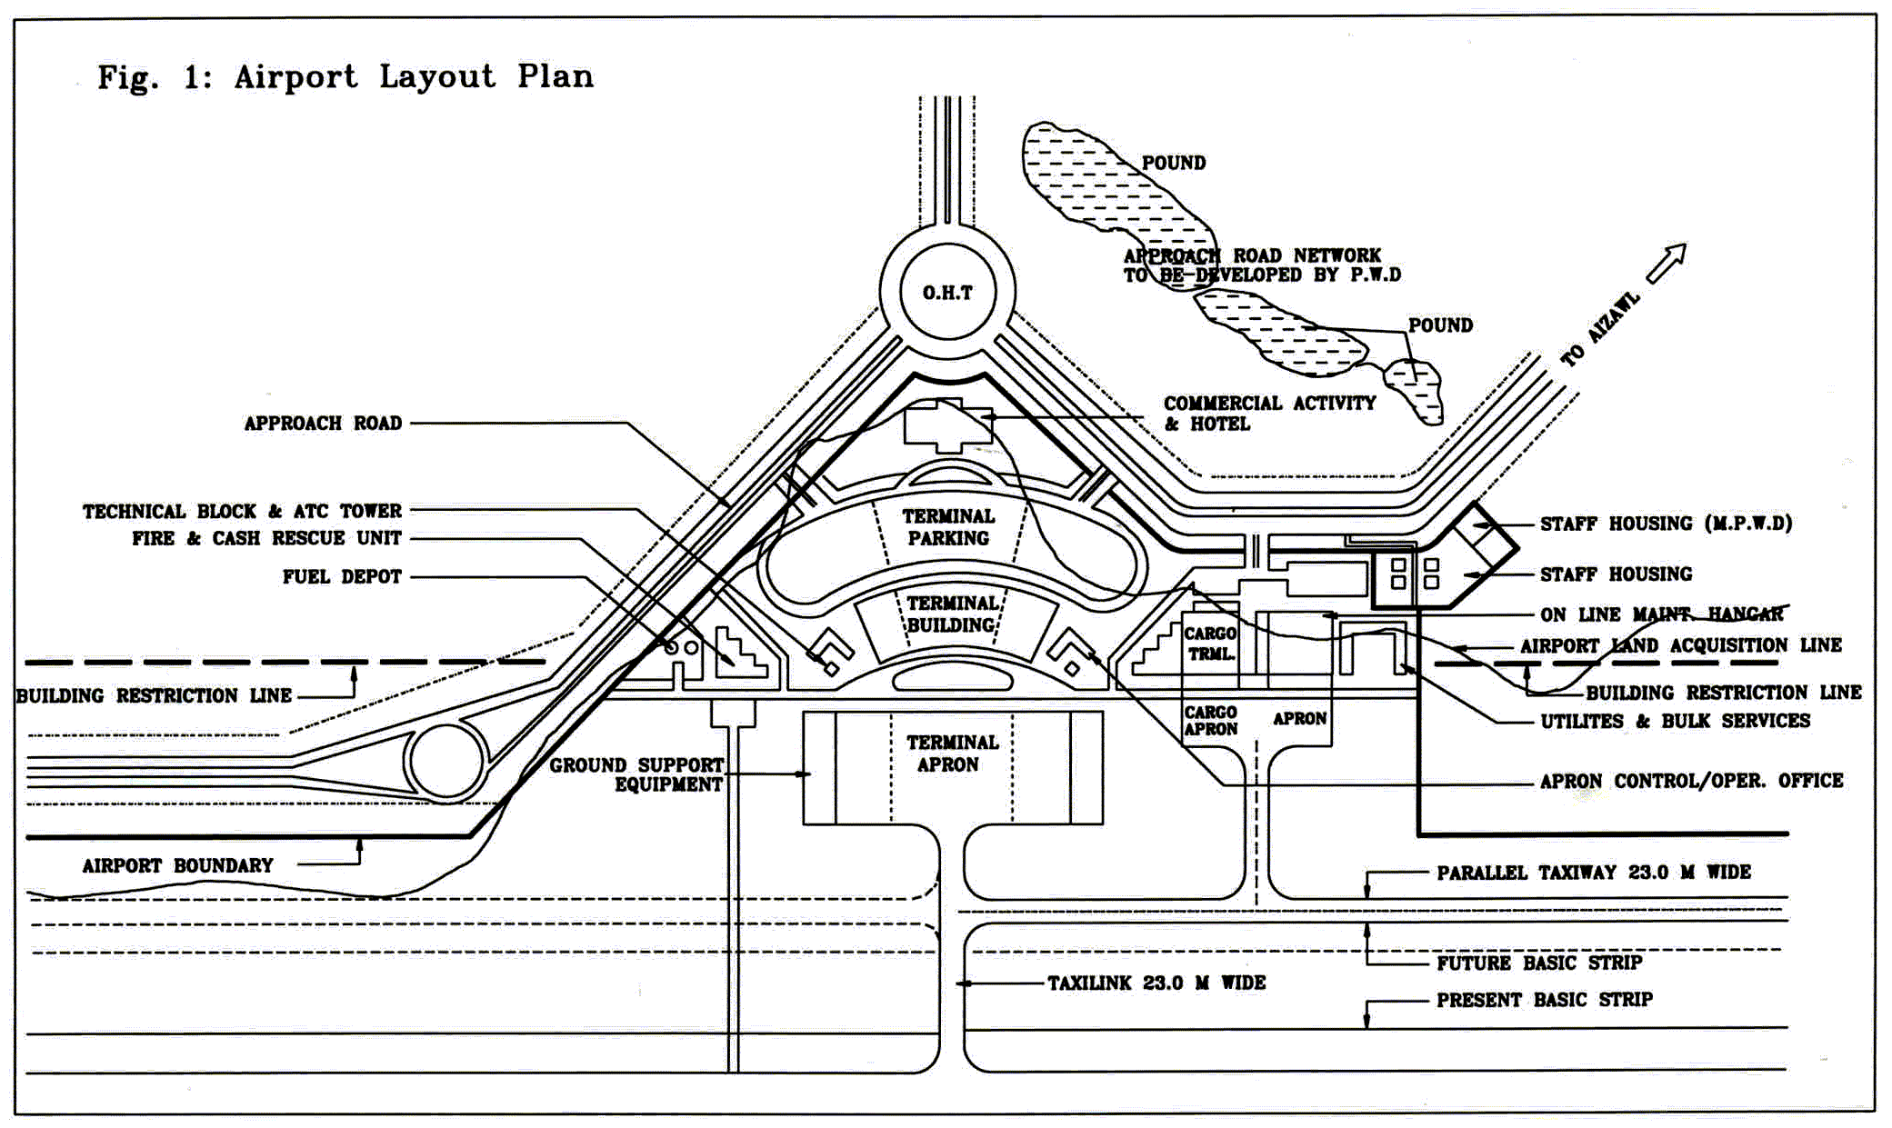

The important dimension of land acquisition in Lengpui is the legal title to it. It was officially announced at the inaugural ceremony of the airport that it received people’s full support and that the landholders donated their plots for its construction and thereby set a remarkable example for others. The only compensation paid by the State was for assets such as trees (NENA Headlines,Vol.1 Issue 30-31,Dec22-Jan6,1999). But as we met the land losers we realised that about 65 percent of the area acquired belonged to some high government officials and political leaders at Aizawl. A close scrutiny revealed that they and other rich persons came to know about the project before the others did and started buying the plots from the people in Lengpui village at a very low price. They then donated the land to the government and created the ‘unique example of people’s cooperation’. The 20 original inhabitants being completely ignorant of it, moved to the outskirts of the village after selling their land to the rich persons for Rs 5,000 per trin (a local measure equal to 1 acre). In some cases the rich paid a lump sum. On an average they received between Rs. 20,000 and 30,000 each for 3 to 4 acres.

Later, the rich persons got compensation as DPs or donors. This is one of many cases of wealthy people compelling the common persons to sell their land thereby hiding the real losers and becoming fake losers. According to official sources 26 persons including a former Chief Minister and some directors of departments were compensated for it (Director, Land Revenue and Settlement Department ND). In the village we met 11 displaced families from whom the Airport Authority took over land directly. Each of them received Rs 5,000 to 20,000 per acre as lump sum compensation though at the time of acquisition they had a standing paddy crop. Some of them got Rs 200-300 per tree. They were unhappy with the compensation and none of them was aware of the criteria for fixing it. Pu Lianzuala, one of them received Rs 74,000 for 10 trins but does not know on what basis it was calculated. The rich who posed as DPs at the time of acquisition received a compensation of Rs 2 lakhs each for the trees and other assets on the land that they had bought from the real owners and later “donated” to the Airport Authority.

Thus, the major issue involved in Lengpui is that the real owners are deceived twice, first by the rich and then by the project authority. It shows the need to check not only for whose benefit the development projects are but also who reaps their benefits. Therefore, the issue of deprivation in Lengpui needs to be studied in two segments i.e. those who had to sell their land and were not recognized as DPs and the real DPs. It is an issue of equality which is the core idea of democracy. In fact the whole idea of democracy in India is confusing since it talks about the will of the majority prevailing on the minority. At Lengpui the displacement of 11 families and deception of 20 others has been overlooked and justified on the plea of the greatest good of the biggest number. It can be questioned on the basis of the well being of the land losers. Can they be impoverished in the name of a greater good? Of greater importance is the law itself. By fixing the date of the notification for the recognition of the owner as DP/PAP it makes deception possible. The poor become poorer and the rich become richer. That goes against the very concept of equality and right to a life with dignity enshrined in Article 21 of the Constitution on right to life. The Apex Court has interpreted it as every citizen’s right to a life with dignity (Vaswani 1992: 158). The impoverishment of the DPs goes against it.

Impact on the Economic Condition of the DP/PAP

However, the people are displaced not according to their right but the State’s powers to acquire land for a ‘public purpose’ (Ramanathan 1999: 19-21). Once evicted from the project site, the families have very little power to live according to Article 21. The 11 displaced families whom we could visit resettled themselves at a spot near the airport where the Airport Authority had planned to build an approach road. So they were displaced once again and they resettled themselves on a plot that the Airport Authority had earmarked for the staff quarters. So in the name of the expansion of the airport, they were evicted for a third time in less than a decade. Now they have resettled themselves at a big distance but fear eviction once again.

All of them were farmers before the project but the project has compelled them to leave their traditional occupation. Now they are earning their livelihood by running petty businesses or have become daily wage earners. Their economic condition has deteriorated. Those who continue to be farmers are finding it difficult to sell their produce in the city market since the present location lacks proper transport facilities. R. Rosiama, one of those who sold the land to the rich told us that she had to close down her shop since the village lacks roads. The project authority had promised them permanent jobs but they were given casual work while building the project. Most permanent employees are from outside the village. Pu Lianzuala left his hereditary occupation of farming and opened a grocery shop with the compensation received. He had to shift to a new area with fewer amenities. “In the expensive lifestyle of Mizoram, that amount is not sufficient to resettle”, he said. No DP was provided transport or any other facility for resettlement. They also incurred expenses to get the compensation by constantly travelling to the office at Aizwal. But the fake PAPs received quite a big compensation with no trouble.

Their displacement for the airport has an adverse impact also on their social condition. All the modern amenities like education, electricity and house have suffered. Deterioration in their economic condition has influenced their social life too. Lack of employment, transport, market etc. has created frustration in their families. Though Mizoram is a dry state, alcoholism is increasing among them. Several other social problems like flesh trade and drug addiction are increasing. A recent study by Zoram Entu Pawl found that majority of the youth are drug addicts. Besides, women who used to work in the fields now are compelled to sit at home.

Possible Future Displacement

There are several proposals for upgrading the airport. The North East Council (NEC), the Planning Commission and the Civil Aviation Ministry want to release some funds for work such as its fire station with state-of-the-art facilities like pumps, water sprinklers and high ladders including snorkels, perimeter road around the airport, strengthening of its roof, terminals as protection against torrential rains and a waiting shed outside the terminal building. Other facilities that the state Civil Aviation Department and NEC want to introduce include the instrument landing system (ILS) and modern fire-tenders from the Czech Republic called fire crush tender that will cost Rs 2.5 crore. AAI has decided to commission a digital current weather information system that can detect any meteorological aberration (The Telegraph 18 December 2006). This upgradation might cause panic among the inhabitants because it may mean more land acquisition, displacement and burden of resettlement and dispossession.

Besides, swirling smoke emitted by the burning of jhum fields in the surrounding high hills is a cause of concern for the airport (The Telegraph 18 December 2006). According to a spokesman the Mizoram government is considering a proposal to relocate the farmers who follow the slash- and-burn method of farming before sowing seeds for the next harvest.

Conclusion

Development is always welcome. In a land locked state like Mizoram, an airport is a genuine need. But, who is losing for whose development? The paper shows the need for a proper investigation of the whole case of land acquisition for the project. It should be done in such a manner that those who are really deprived get justice. Besides, the project should provide employment opportunities to the villagers so that the economic frustration that leads to social unrest can be reduced. Proper attention should be paid to the availability of basic amenities. NGOs can come forward to do it and to eradicate the social evils already generated by the project. Finally one has to create a monitoring system free from pressure and with coordination with the neighbours. These steps will not only put an end to the sufferings of the DPs and PAPs but also create an awareness of the oppression by the Creamy Layer of society.

References

Cernea, Michael M. 2000. ‘Risks, Safeguards and Reconstruction: A Model for Population Displacement and Resettlement,’ in Michael Cernea and Christopher Mc Dowell (ed.). Risks and Reconstruction: Experiences of Resettlers and Refugees. Washington DC: The World Bank, Pp 11-55.

Director of Economics and Statistics, 2004. Statistical Handbook of Mizoram. Aizawl: Directorate of Economics and Statistics, Government of Mizoram.

Director, Land Revenue and Settlement Department. File no.31/3GAD. Aizawl: Office of the Land and Revenue Settlement.

Fernandes, Walter 2007. ‘Singur Displacement Scenario’ Economic and Political Weekly. 42 (n. 3, Jan. 20-26), .Pp 203-206.

Fernandes, Walter and Gita Bharali. 2006. Development Induced Displacement and Deprivation in Assam1947-00: A Quantitative and Qualitative Study of Its Extent and Nature. Guwahati: North Eastern Social Research Centre (mimeo).

Ramanathan, Usha, 1999. ‘Public Purpose: Points for Discussion,’ in Walter Fernandes (ed). The Land Acquisition (Amendment) Bill 1998, New Delhi: Indian Social Institute, Pp19-25.

Ramanathan,Usha and Smitu Kothari: 1999, ‘ The Land Acquisition Amendment Bill1998: Some Comments and Partial Appraisal,’ in Walter Fernandes (ed). Op. cit. pp. 10-18.

Vaswani, Kalpana.1992. “Rehabilitation Laws and Policies: A Critical Look’ in Enakshi Ganguly Thukral (ed). ‘Big Dams, Displaced People: Rivers of Sorrow, River of Change’. New Delhi Sage Publication. Pp. 155-168.

Paper presented at the National Seminar on Problem of Displacement in Northeast India, Department of Political Science, Assam University, Silchar, February 8-9, 2007. Ms Pranami Garg is Research Asspciate at North Eastern Social Research Centre, 110 Kharghuli Road (1st floor), Guwahati 781004. Tel. (0361) 2602819. M. 9864101714. Email: nesrcghy@gmail.com; zoomees@gmail.com

