In India, Doubts Gather Over Rising Giant's Course
The Wall Street Journal, Wednesday, March 30, 2011-03-30
http://online.wsj.com/article/SB10001424052748703313304576131792120382006.html?mod=WSJINDIA_hpp_MIDDLELSMini_1

By PAUL BECKETT
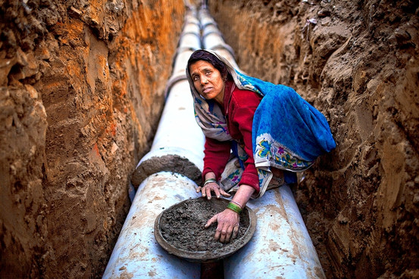Getty Images
An Indian woman working construction in New Delhi. Concerns are growing that the benefits of India's rapid growth haven't spread widely enough.
NEW DELHI—India's economy is going great guns. Among the world's major nations, its growth is second only to China's. Yet in recent months, the mood in the planet's most-populous democracy has soured badly—to the point where even some of India's richest people have begun to complain that things are seriously amiss.
No one is disputing that the boom has created huge wealth for the business elite and much better lives for hundreds of millions of people. But the benefits of growth still haven't spread widely among India's 1.2 billion residents. And a string of corruption scandals has exposed an embarrassing lack of effective governance.

India's Growth Battle
View Interactive
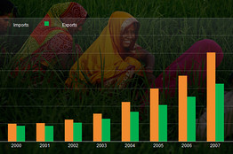
India's Growth Battle
In a recent television appearance, Azim Premji, chairman of software-services giant Wipro Ltd., described the situation as a "national calamity." Mr. Premji and 13 others—business leaders, retired Supreme Court justices and former governors of India's central bank—laid out their complaints in January in an open letter to "our leaders." "It is widely acknowledged that the benefits of growth are not reaching the poor and marginalized sections adequately due to impediments to economic development," they wrote.
This wasn't supposed to be the picture 20 years after India abandoned its Soviet-style, centrally planned economic model, embraced capitalism and jump-started economic growth. Historic reforms begun in 1991 held out the promise of transforming the country from an agrarian backwater into an industrial powerhouse, lifting almost everyone's standard of living in the process. Other Asian nations, including China and South Korea, have traveled that path successfully.
India enjoyed years of heady growth, despite problems its East Asian peers didn't share, such as its deep caste divisions. Now, though, a host of problems has stalled the transformation.The public-education system is a shambles. No significant publicly owned businesses have been privatized in years. The promised modernization of the financial system has happened only in fits and starts. Land reform needed to stimulate industrialization has been a political nonstarter. And malnutrition remains widespread.

Flawed Miracle
The Journal is examining the threats to, and limits of, India's economic ascent. Rajiv Kumar, director general of the Federation of Indian Chambers of Commerce and Industry, says that because India has failed to follow through with many reforms, the nation "is in danger of losing its momentum." Even senior government officials acknowledge they need to hit the restart button on reform. "We must quickly rediscover the old sense of boldness and take the bold decisions, which I'm sure we will," Home Minister Palaniappan Chidambaram, who played a key role in the 1991 reforms, said in a recent interview. The government, he said, has taken several steps recently to help the poor, setting up a midday meals program in schools and proposing a law to make access to food a fundamental right.
Ravi Venkatesan, until this week chairman of Microsoft Corp.'s India arm, says his nation is at a crossroads. "We could end up with a rather unstable society, as aspirations are increasing and those left behind are no longer content to live out their lives. You already see anger and expressions of it," he says. "I strongly have a sense we're at a tipping point: There is incredible opportunity but also dark forces. What we do as an elite and as a country in the next couple of years will be very decisive."
India's fate is vital to the U.S. and other Western powers, which view the nation as an important and growing export market, a stabilizing force in a dangerous region, and a counterweight to a surging China.
India's economic liberalization was kicked off by a financial crisis in 1991, when the nation was on the verge of defaulting on its debt. Manmohan Singh, the nation's current prime minister, was finance minister at the time. The initiatives he introduced staved off financial collapse. By ditching the old system of industrial central planning, India unleashed entrepreneurial forces, stimulated trade and attracted foreign investment.Economic growth, which had fallen to about 1% in 1991, quickly picked up. "India is on the move again," Mr. Singh declared to India's parliament in February 1992. "We shall make the future happen."
In many important respects, the changes turned this nation into a success story. Life expectancy rose to 64 years in 2008, from 58 in 1991. Literacy has risen. Hundreds of millions have seen their incomes improve. Per capita gross domestic product increased to $3,270 in 2009, from $925 in 1991, according to the World Bank.
Industries once dominated by the state, such as airlines and telecommunications, now are led by private-sector companies. India's outsourcing industry is admired world-wide for its expertise and low costs. The southern city of Chennai is a fast-growing automotive manufacturing center. These days, India often is held up as an example of how a democracy in Asia can mirror the spectacular growth of authoritarian China. In the year ending March 31, India's economy is expected to expand by about 8.5%.
Other important gauges of national well-being paint a more troubling picture. "What has globalization and industrialization done for India?" asks Mr. Venkatesan, Microsoft's former India chairman. "About 400 million people have seen benefits, and 800 million haven't."
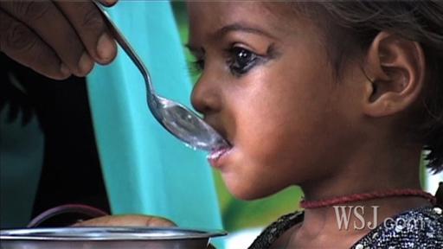
Many feel India will need to reduce rampant malnutrition if it wants to have the workforce it will need to compete as a global superpower. WSJ's Geeta Anand reports.
Calorie consumption by the bottom 50% of the population has been declining since 1987, according to the 2009-10 economic survey conducted by India's Ministry of Finance, even as those at the top of society struggle with rising obesity. Mainly because of malnutrition, around 46% of children younger than 3 years old are too small for their age, according to UNICEF.
Infrastructure in cities and the countryside remains woefully inadequate: In recent years, China has added, on average, more than 10 times as much power as India to its electricity grid each year.
Data from McKinsey & Co. show that the number of households in the highest-earning income bracket, making more than $34,000 a year, has risen to 2.5 million, from 1 million in 2005. But the ranks of those at the bottom, making less than $3,000 a year, also have grown, to 111 million, from 101 million in 2005.
Mr. Singh, in a speech to parliament in 1991 upon unveiling major reforms, said he wanted to avoid what he considered to be the ills of unabashed spending. "My purpose is not to give a fillip to mindless and heartless consumerism we have borrowed from the affluent societies of the West," he said.
But among the most visible signs of India's modernization is an entrenched consumerist creed. Sales of luxury goods are booming. Mansions are replacing one-story homes in middle-class neighborhoods. Upscale malls are sprouting up around the country.
Many of the urban poor, in contrast, are slipping backward because of rising prices—a persistent and destructive accompaniment to India's high growth rate. Much of that inflation is in basic foods. Some economists say one cause is the government's reluctance to allow the development of agribusiness or to break down barriers to interstate trade, which would increase productivity in the countryside.
Food inflation today is running at about 10%, and general inflation in excess of 8%.
"We are the most affected by the rise in prices, though it hardly affects the rich," says Manohar Singh, 44, a rickshaw puller in Dehli. "I don't have money to treat my tuberculosis, which was detected sometime back. We are not able to feed our children, leave aside medical aid and sending them to school."
He says the owner of his rickshaw, which he rents, has increased the rent, but customers refuse to pay more.
Politics are partly to blame for stalling the liberalization drive. The Congress party, which has ruled the nation for most of the 64 years since India gained independence from Great Britain, depends on smaller regional parties to maintain its governing coalition in parliament. That makes policy formulation risk-averse, since small allies hold the power to break ranks and sink the coalition.
Prime Minister Singh, now 78, doesn't have sole authority to push new policies. Though he is prime minister, the most powerful politician in India is Sonia Gandhi, widow of assassinated former Prime Minister Rajiv Gandhi. She is president of the Congress party, which leads the governing United Progressive Alliance government. She effectively holds a veto over policy decisions.
The current government has been distracted by revelations about corruption. Reforms were supposed to reduce graft by ending the "License Raj," a widely corrupt system of government permits and permissions that determined economic activity. In addition, the government reduced the tax burden on individuals and companies to encourage greater compliance.
But corruption is considered more prevalent now than ever before, because economic expansion has created more opportunities for graft—for example, in the granting and funding of infrastructure projects.
Revelations in the fall that a flawed and allegedly corrupt allocation of mobile-telephone spectrum in 2008 had deprived the government of billions of dollars in potential revenue disrupted the entire winter session of parliament, adding to the frustrations of business leaders who want to see new liberalization laws enacted.
The amount of business activity that evades direct taxes has soared, says Arun Kumar, chairman of the Center for Economic Studies and Planning at Jawaharlal Nehru University in New Delhi and a specialist on the "black economy."
A landmark study in the mid-1950s, he says, estimated that the black economy accounted for 4% to 5% of India's gross domestic product. Rather than declining, he says, the black economy has become systemic. He estimates it reached 40% of GDP by 1996, and 50% by 2006.
"The reason it has grown is that illegality in society has become more and more tolerable," he says.
At a February press conference, Mr. Singh said the government is determined to root out corruption. "I wish to assure you, and I wish to assure the country as a whole, that our government is dead serious in bringing to book all the wrongdoers, regardless of the position they may occupy," he said.
India's modernization was expected to prompt a mass movement of workers from farms to factory floors—a critical component in the transformation of China, South Korea and other Asian nations. But manufacturing as a share of India's economy stood at 16% in 2009, the same as in 1991, according to the World Bank.
Services have increased dramatically as a proportion of gross domestic product, rising to 55% in 2009, from 45% in 1991, according to the World Bank, becoming the chief engine of India's economic strength. But many of the fastest-growing areas, such as finance and technology, employ relatively few and rely heavily on skilled employees. The entire software and technology-services sector, including call centers and outsourcing, directly employs just 2.5 million workers, a tiny fraction of the overall work force.

India Real Time
- HCL Chief Sees India at a Crossroads
- Kaushik Basu Says Make Bribe Giving Legal
Agriculture's share of the economy, meanwhile, has declined to about 17% in 2009, from 30% in 1991. But the number of people working in agriculture hasn't dropped commensurately, according to Arvind Panagariya, a professor of Indian political economy at Columbia University in New York. "The dependence on agriculture remains incredibly high when you compare India's high-growth phase with others," he says. "The potential of the country is to grow at 11% to 12%, and it's growing only at 8% to 9%."
Frustration over the economic miracle's limited trickle-down is fueling political movements around the country. Most base their appeal, in part, on the idea that the poor are being ill-served in the new India.
A decades-old Maoist insurgency seeks the overthrow of the Indian state. The prime minister has called the insurgents' brand of left-wing extremism the nation's biggest internal security threat.
In India's most populous state, Uttar Pradesh, Chief Minister Kumari Mayawati has positioned herself as a vocal critic of the Delhi government and champion of the downtrodden. In West Bengal, Mamata Banerjee, currently railways minister in the central government, shot to prominence advocating farmers' land rights against plans by the Tata Group to establish a car factory near Kolkata, the state capital. A long-simmering insurgency in Indian-run Kashmir, the disputed Himalayan area that straddles India and Pakistan, erupted last year in part over the lack of economic opportunity for the region's youth.
In a speech last weekend to a group of businesspeople, Prime Minister Singh pledged government action. "I affirm our commitment to a new wave of reform," he said. "I am aware of the fact that much more needs to be done to make our economy more competitive."
—Vibhuti Agarwal and Krishna Pokharel contributed to this article.
Write to Paul Beckett at paul.beckett@wsj.com

